**ATTACHMENT 1: TRAFFIC MANAGEMENT PLAN  
CHECKLIST FOR OVER-WIDTH AGRICULTURAL VEHICLES  
OR COMBINATIONS**

1. **DETAIL OF OWNER AND OPERATORS**

|  |  |  |  |
| --- | --- | --- | --- |
| Business name: | | | |
| Business address: | | | |
| Owners Name: | Mobile: | Work phone: | Email: |
| Operators name: | Mobile: | Work phone: | Email: |
| 1st Escort/Pilot name: | Mobile: | Work phone: | Email: |
| 2nd Escort/Pilot name: | Mobile: | Work phone: | Email: |
| Communication Mode: | Type: | Band: | Channel: |

1. **CHECKLIST OF AGRICULTURAL VEHICLE/COMBINATION DETAIL**

**Dimension of vehicle/combination**

|  |  |  |  |
| --- | --- | --- | --- |
| **Dimension** | **Vehicle 1** | **Implement 2** | **Implement 2** |
| Width | m | m | m |
| Length | m | m | m |
| Height | m | m | m |
| Rear overhang | m | m | m |
| Front projection | m | m | m |
| Mass | t | t | t |

**Description (make and model of any machinery)**

|  |
| --- |
|  |
|  |
|  |
|  |
|  |

1. **ROUTE DETAILS**

Route details can be recorded by the roads travelled in sequence or on a map (example below) with the route clearly marked or a both.

**Proposed Route (roads to be travelled on or crossed in sequence of travel)**

|  |
| --- |
|  |
|  |
|  |
|  |
|  |
|  |
|  |
|  |
|  |
|  |
|  |
|  |

Simple maps of the routes to be taken and the pull of points as risk mitigating actions.

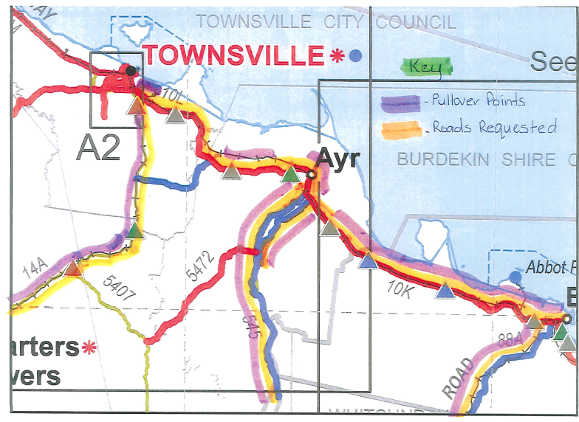

1. **CHECKLIST OF RISK ASSESSMENT REQUIREMENTS**

Route analysis of the proposed trip is required to identify restrictions, clearance points and advice which may affect the operation of an over width agricultural vehicle/combination.

Required Information Includes:

1. **Restrictions:**

* Barriers, bridge size & handrails, culverts, cutting, traffic island, level crossing, overhead obstruction, vehicle parking areas, roundabout, screen traffic sign, street light, traffic lights, trees.
* Impact the restriction has on the movement.
* Plans to navigate through the restrictions.

1. **Clearance Points:**

* Heavy vehicle rest area, heavy vehicle stopping place, feeder lane, extended shoulder, overtaking lane, slip lane, turn lane, inspection point, pull over point and rest stops.
* How and when the clearance points are to be used and how traffic is to safely pass.

1. **Advice:**

* Average road width, lane description, contra flow requirements, steep incline.
* Activities which may impact on the movement, schools, school bus routes, road works.
* Travel restrictions, time of day, restricted access areas.
* Requirement to move TMR road side furniture.
* Requirement to move equipment owned by other authorities.

1. **RISK ASSESSMENT AND MITIGATING ACTIONS**

The following table can be used to assess the risks and provide the mitigating or preventative action required. Alternatively, the information can be added to a map as above for pull off points.

| **Risks description and position on the route** | **Likelihood** | **Preventative action** | **Contingency plan** |
| --- | --- | --- | --- |
|  |  |  |  |
|  |  |  |  |
|  |  |  |  |
|  |  |  |  |
|  |  |  |  |
|  |  |  |  |
|  |  |  |  |

1. **CHECKLIST OF APPROVALS FROM LOCAL AUTHORITIES**

**Approvals from Queensland Police Service**

Where the dimensions of an oversize vehicle or combination are listed in a Guideline or approval as requiring a Queensland Police Service permit, approval to operate must be obtained.

Further information and contact details can be found under the Queensland Police Service website [www.police.qld.gov.au](http://www.police.qld.gov.au/) Select Corporate Documents: Police Wide Load Escorts.

**Rail Approval**

Where the height dimension of an oversize vehicle or combination is likely to interfere with overhead wires or falls within the exclusion zone specified for overhead wires, approval to operate must be obtained from the relevant authority.

Where the width and length dimension of an oversize vehicle or combination exceeds specified dimensions, approval to operate must be obtained from the relevant authority.

If your vehicle or proposed load requires a height, width or length approval you must provide permits for each railway crossing on the route.

Vehicle or vehicle combination requires an approval: **Required: Yes / No**

**Electrical Authority Approval**

Where the height dimension of an oversize vehicle or combination is likely to interfere with overhead wires or falls within the exclusion zone specified for overhead wires, approval to operate must be obtained from the relevant authority.

If your vehicle or proposed load requires a height approval you must provide permits for the entire route.

Vehicle or vehicle combination requires an approval: **Required: Yes / No**

**Telecommunication Authorities**

Where the height dimension of an oversize vehicle or combination is likely to interfere with overhead wires, approval to operate must be obtained from the relevant authority.

If your vehicle or proposed load requires a height approval you must provide permits for the entire route.

Vehicle or vehicle combination requires an approval: **Required: Yes / No**

1. **CHECKLIST OF TRAVEL RESTRICTIONS WHICH AFFECT AREA AND ROADS**

Identify travel restrictions to prescribed roads and areas which may affect the movement.

**Area Restrictions**

Where the operation of the vehicle combination is affected by ‘Area’ restrictions the restrictions must be noted on the TMP.

Area restrictions worth noting: **Required: Yes / No**

**Time of Day Restrictions**

Where the operation of the vehicle combination is affected by ‘Time of Day’ restrictions the restrictions must be noted on the TMP.

Time of day restrictions worth noting: **Required: Yes / No**

**Public Holiday Restrictions**

Where the operation of the vehicle combination is affected by ‘Public Holiday’ restrictions the restrictions must be noted on the TMP.

Public holiday restrictions worth noting: **Required: Yes / No**

**Approval Restrictions**

Where the operation of the vehicle combination is affected by ‘Approval’ restrictions the restrictions must be noted on the TMP.

Area restrictions worth noting: **Required: Yes / No**

1. **RISK ASSESSMENT SIGN-OFF**

I hereby certify that the information supplied herein is correct, and in my authorised capacity, I accept liability for any damage done to any road declared under the Transport Infrastructure (Roads) Act 1994, and indemnify the Director General against any claim which may be sustained against him by reason of the use of any declared road for the purpose mentioned.

|  |  |
| --- | --- |
| **Transport Operator or Contact Person Full Name (print):** |  |
| **Position:** |  |
| **Transport Operator or Contact Person Signature:** |  |
| **Date:** |  |